Name:  Teacher : | ____________________________________  ______________________ |  | Date:_________
 | Year 7  In class  Transformations and Symmetry
Total Time: |  | Conditions: Calculator allowed
Weighting:
Equipment: | Calculator, pen, pencils, eraser

A transformation occurs when an ‘object’ is moved, reflected, rotated or changed in size.
This investigation will focus on:
- Translations (moved by ‘sliding’ left/right or up/down)
- Reflections (moved by ‘flipping’ over a line)
- Rotations (moved by ‘turning’ clockwise or anticlockwise)

For the purposes of this investigation, an ‘object’ is any two dimensional shape and is named by its vertices. You can start from any vertex and move in either a clockwise or anticlockwise direction.
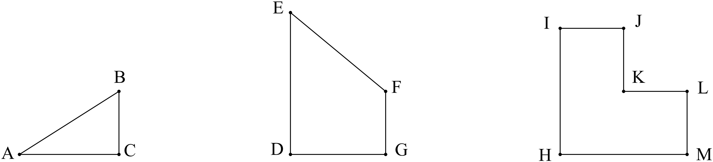i.e.

object ABC object DEFG object HIJKL

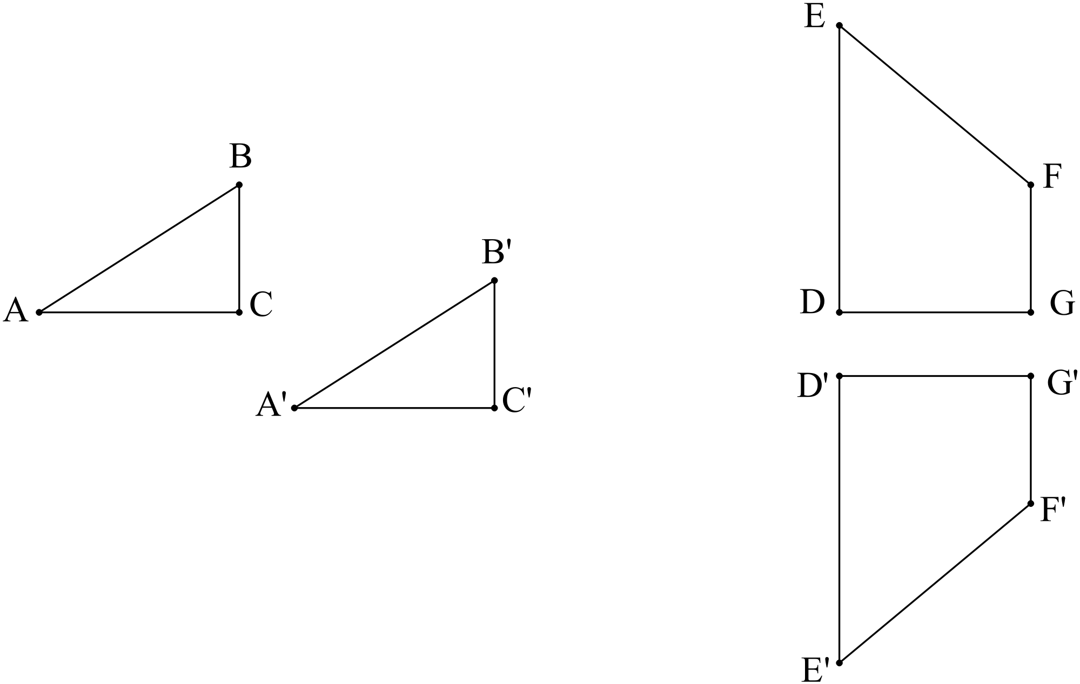When an ‘object’ is transformed the result is its ‘image’. We use apostrophes to represent the image.
i.e.

object DEFG
image D’E’F’G’

object ABC has image A’B’C’

Question 1
- Name the following objects in the spaces provided:
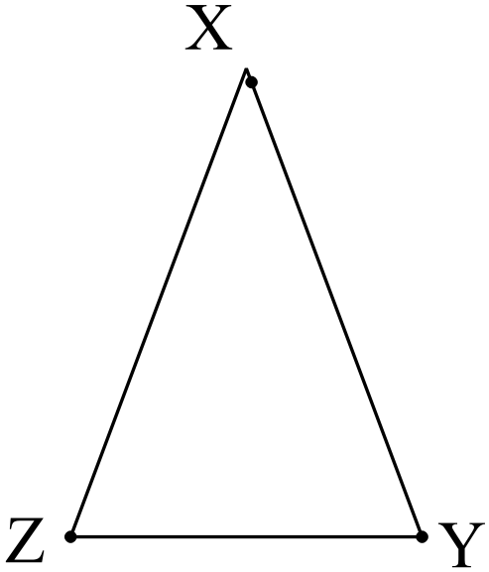
- 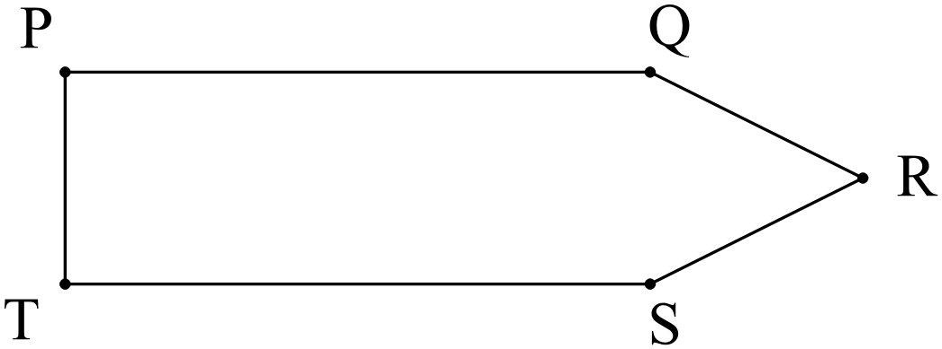 ii)

__________________ ____________________

- 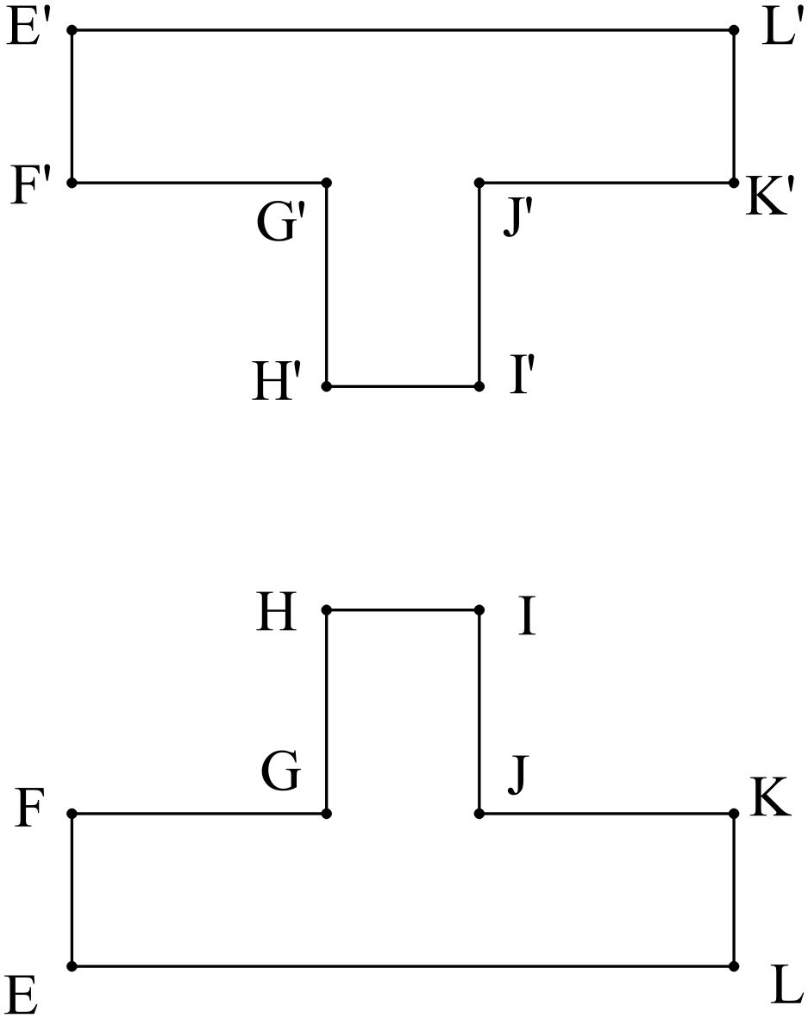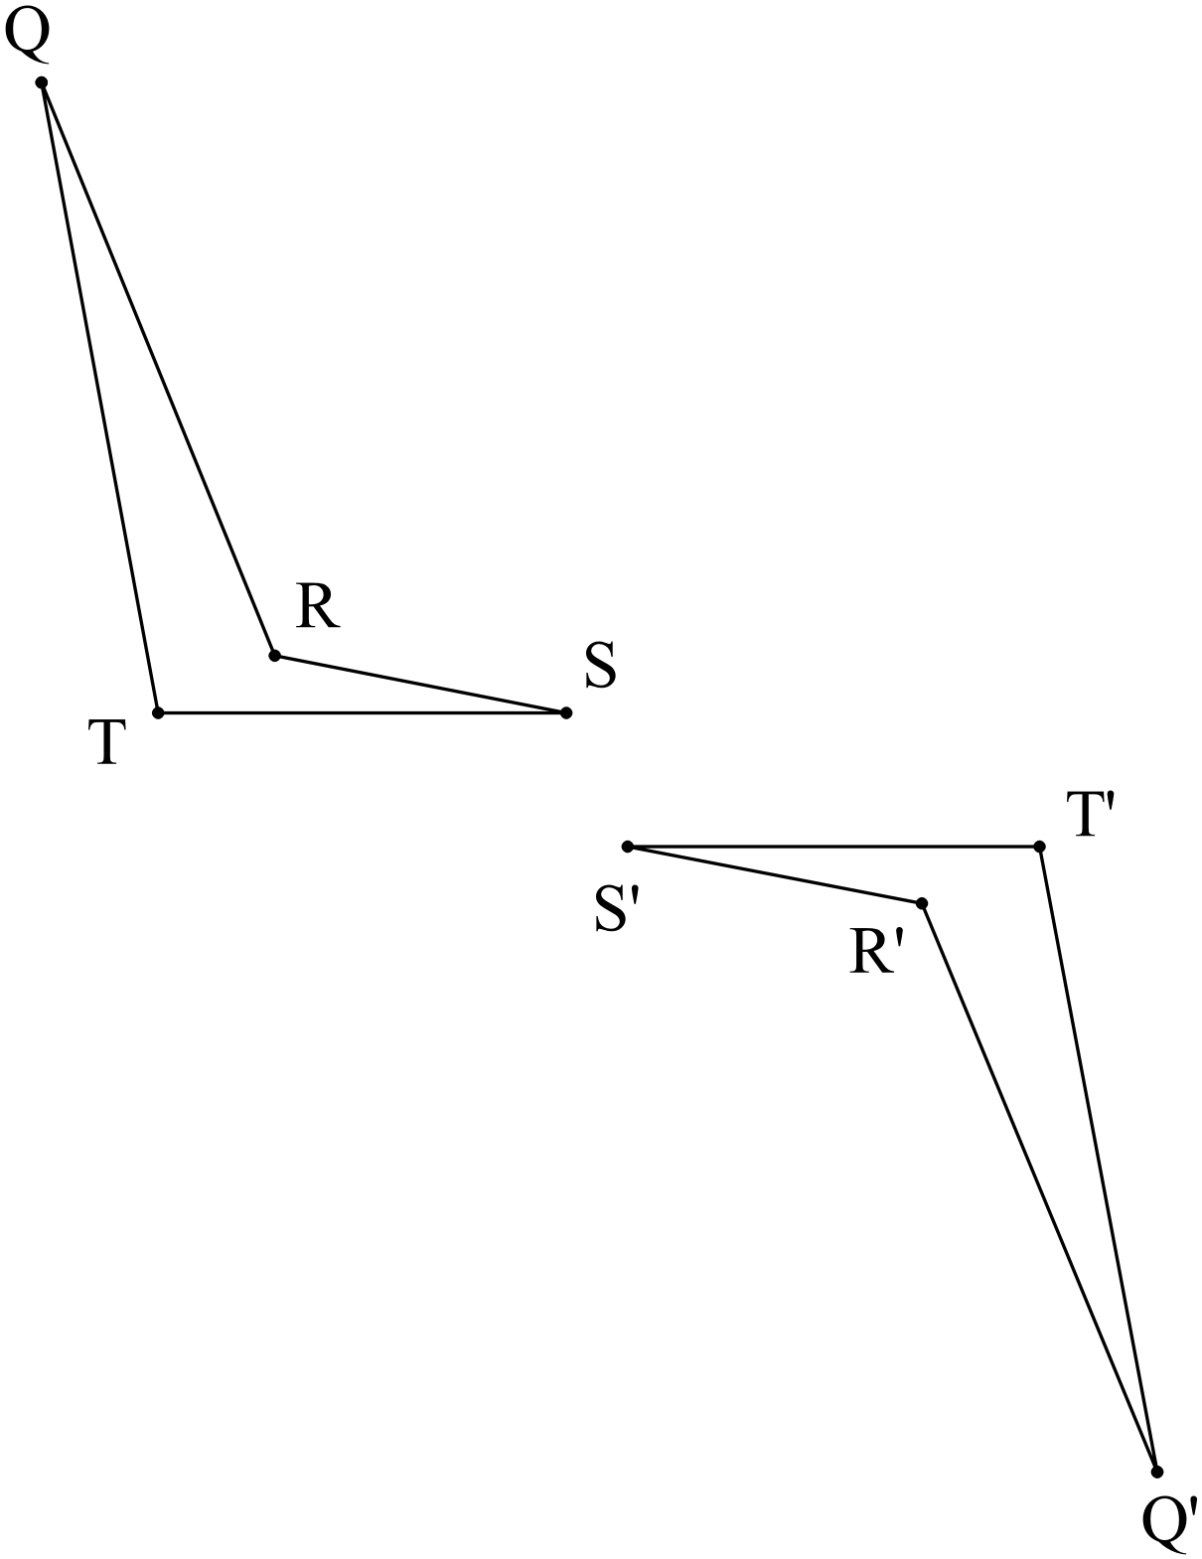Name the object and corresponding (matching) image in the diagrams below:
i) ii)

object: ________________ object: _________________
image: ________________ image: _________________

Translations
A translation is a ‘slide’.
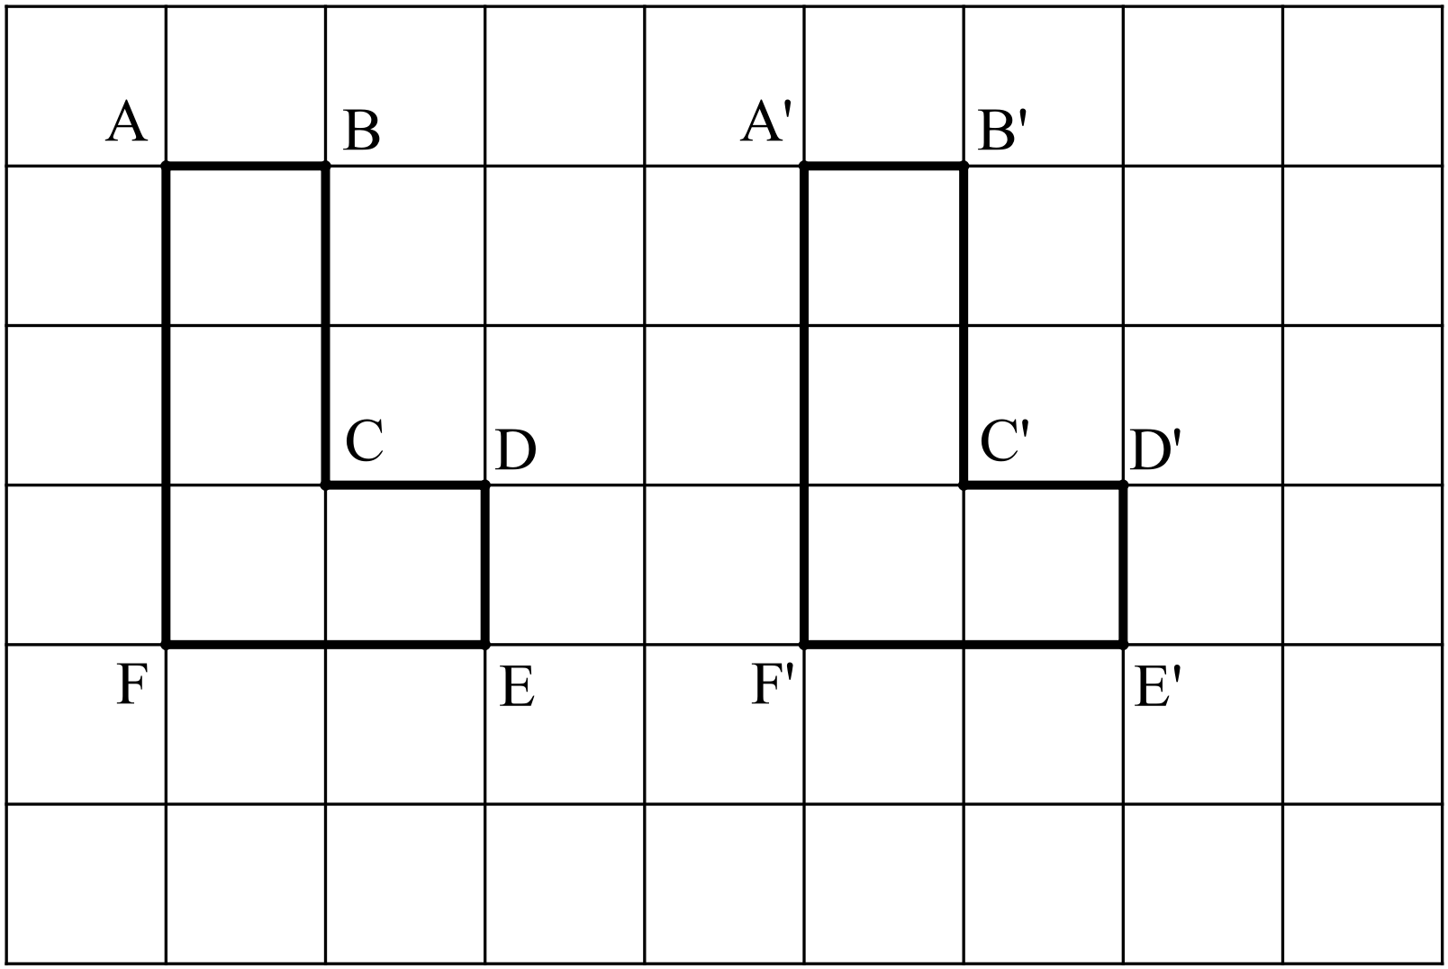We can slide the shape up or down and/or left or right.
Object ABCDEF has been translated 4 units right.

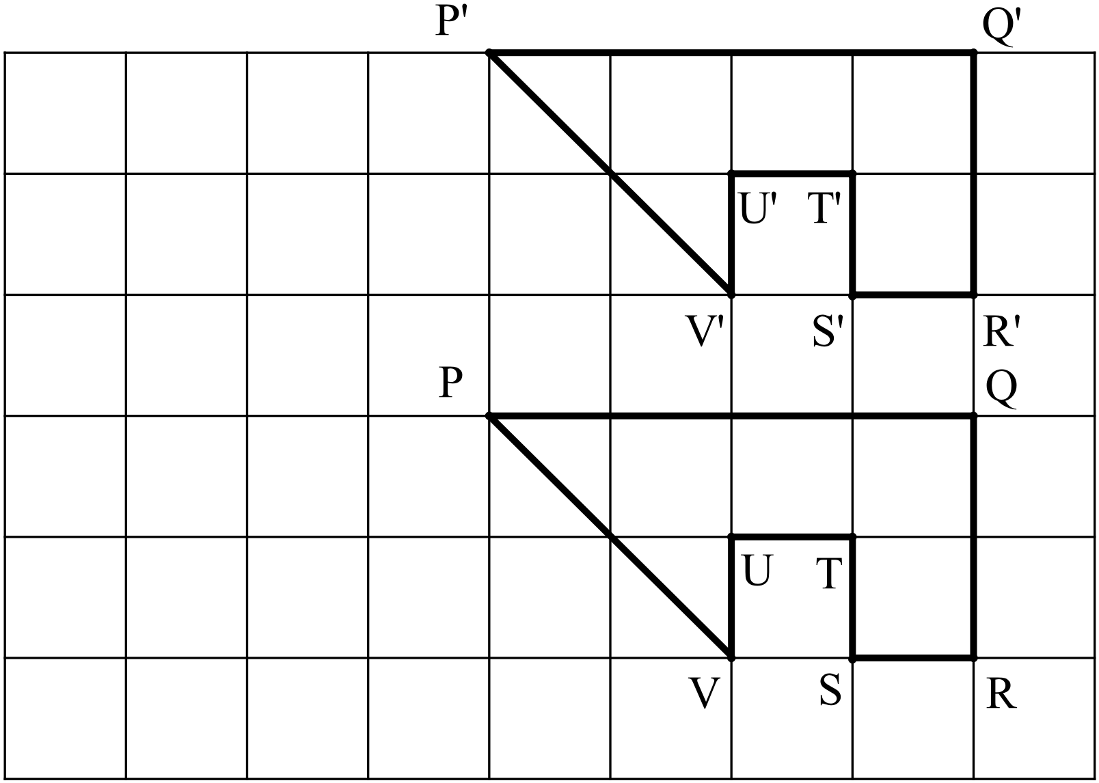

Object PQRSTUV has been translated 3 units up.

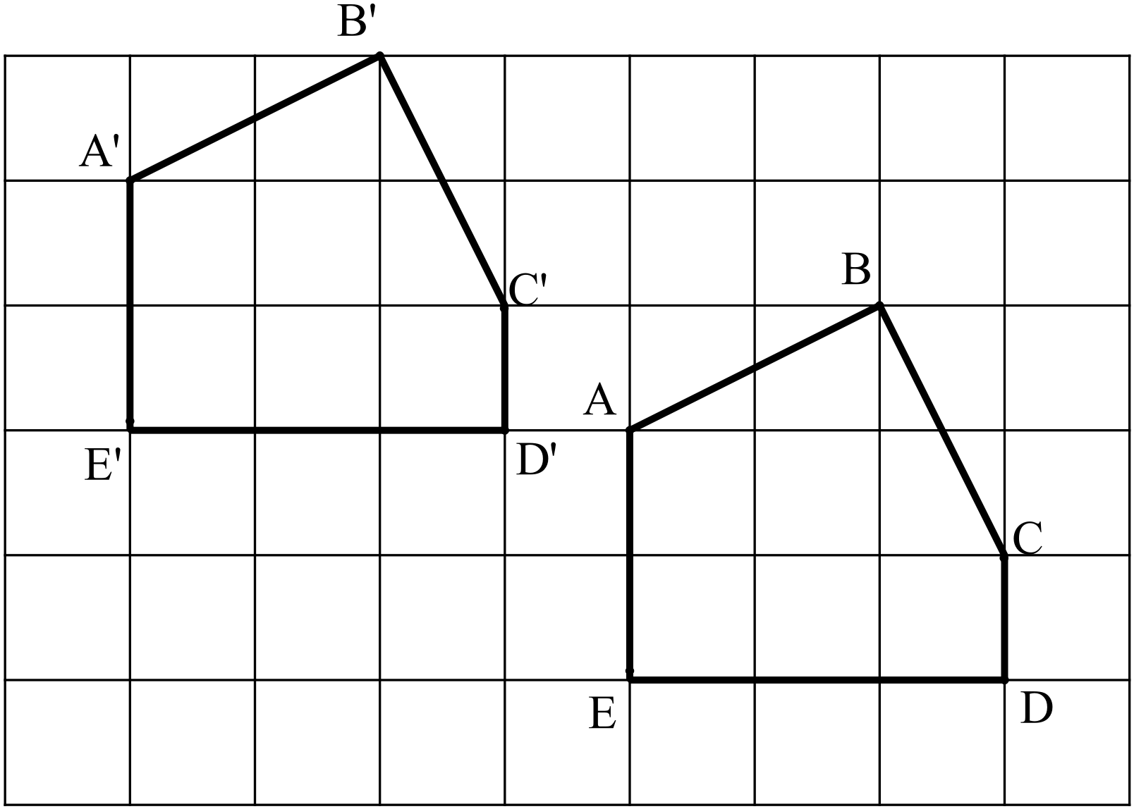
Object ABCDE has been translated 4 units left and 2 units up.

Question 2
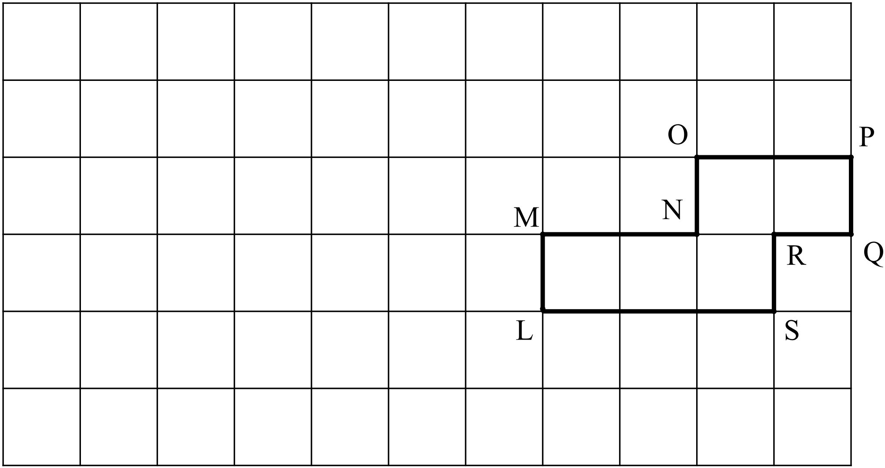Draw the image resulting from the following transformations:
Label the vertices of the image appropriately.

- Translate 5 units left

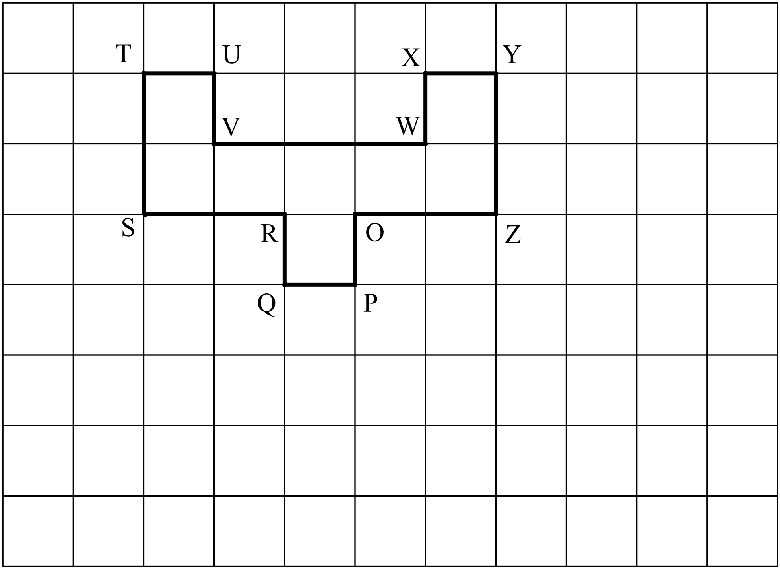
- Translate 4 units down

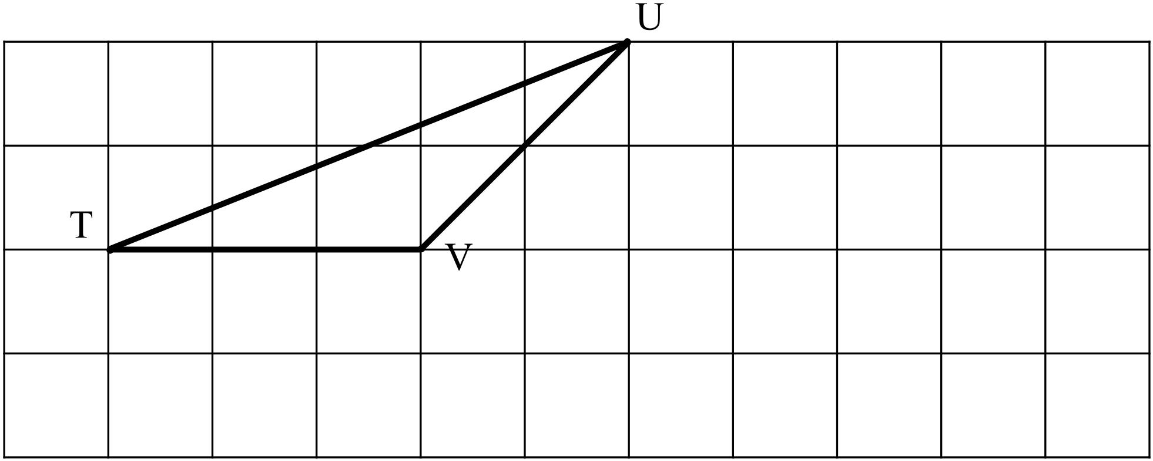
- Translate 2 units right and 1 unit down

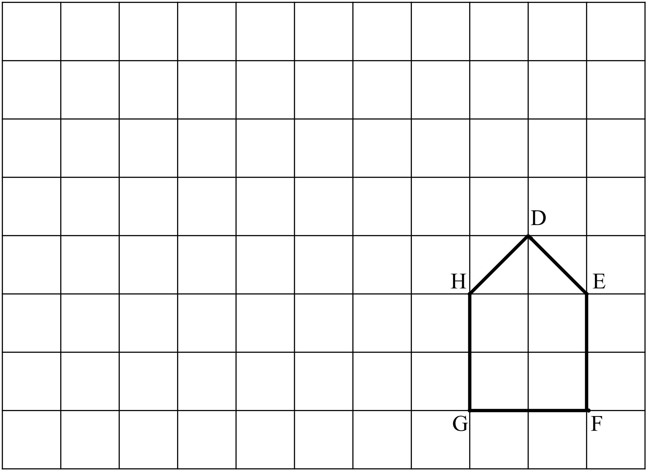

- Translate 4 units left and 3 units up

Question 3
What is the transformation that translates the object to the image in the following?
- 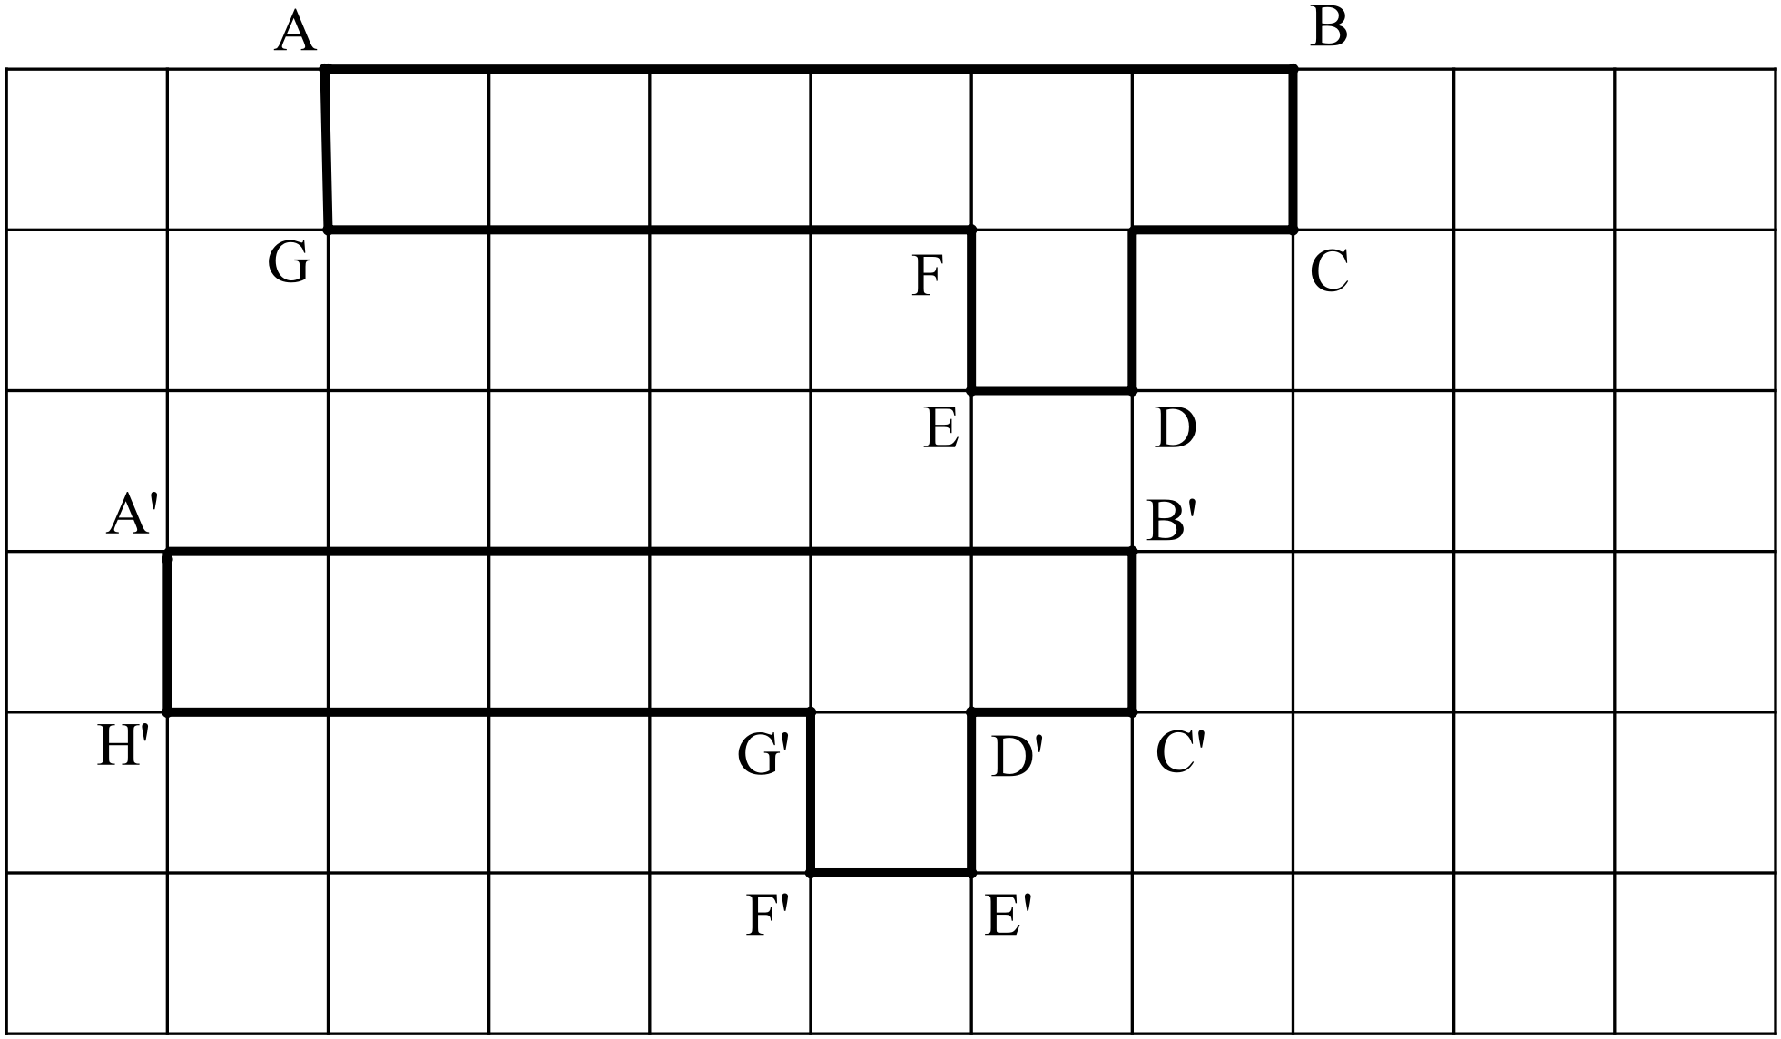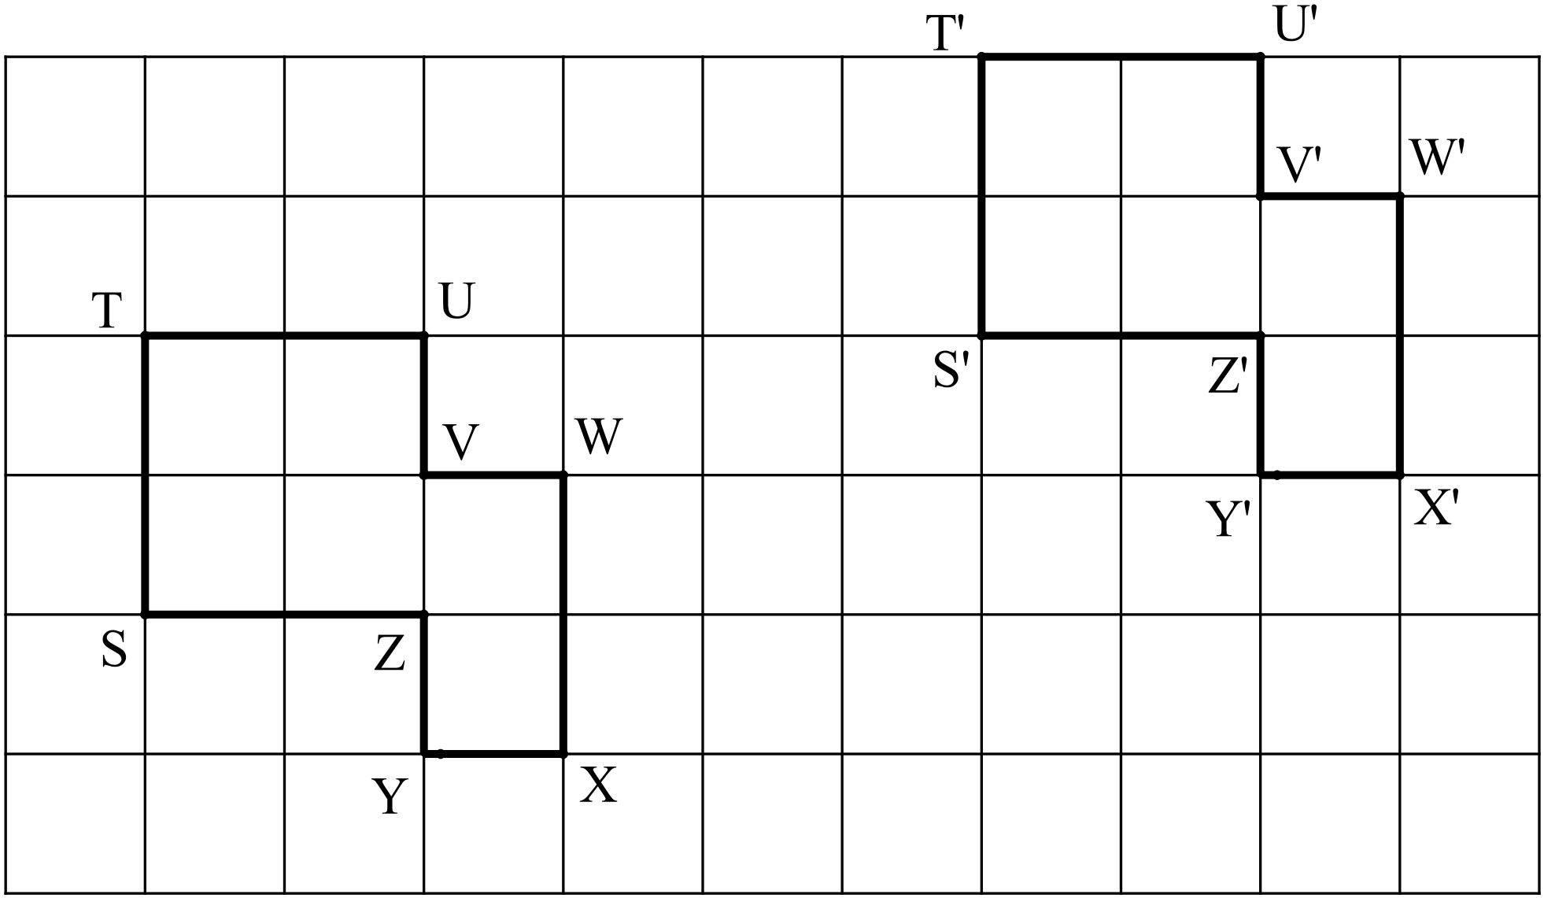 b)

Reflections
A Reflection is a ‘flip’ over the ‘line of reflection’.
The reflection ‘flips’ perpendicular (90°) to the reflection line.
The image is always the same distance from the reflection line as the object.
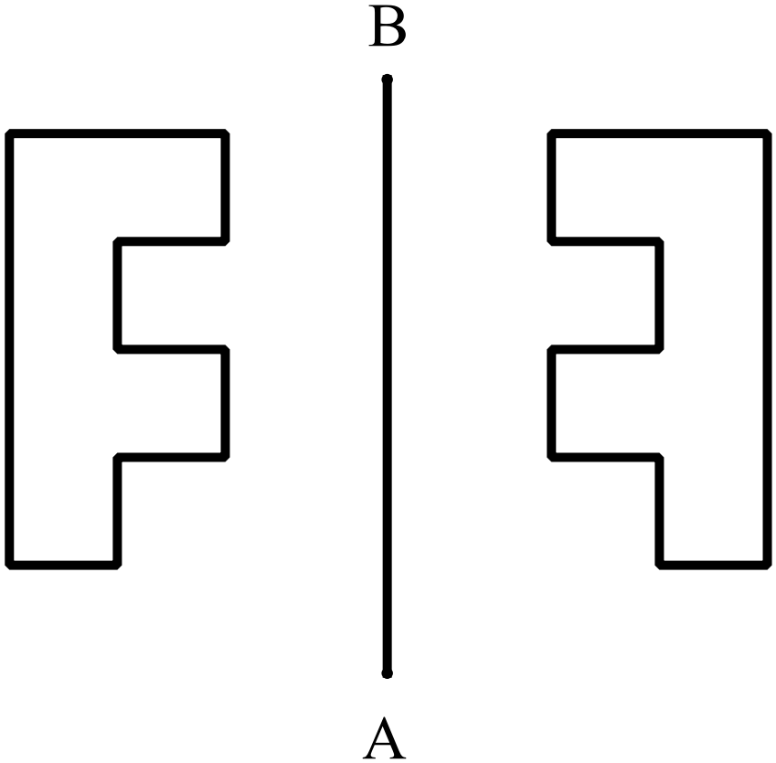The following are reflections over the line AB
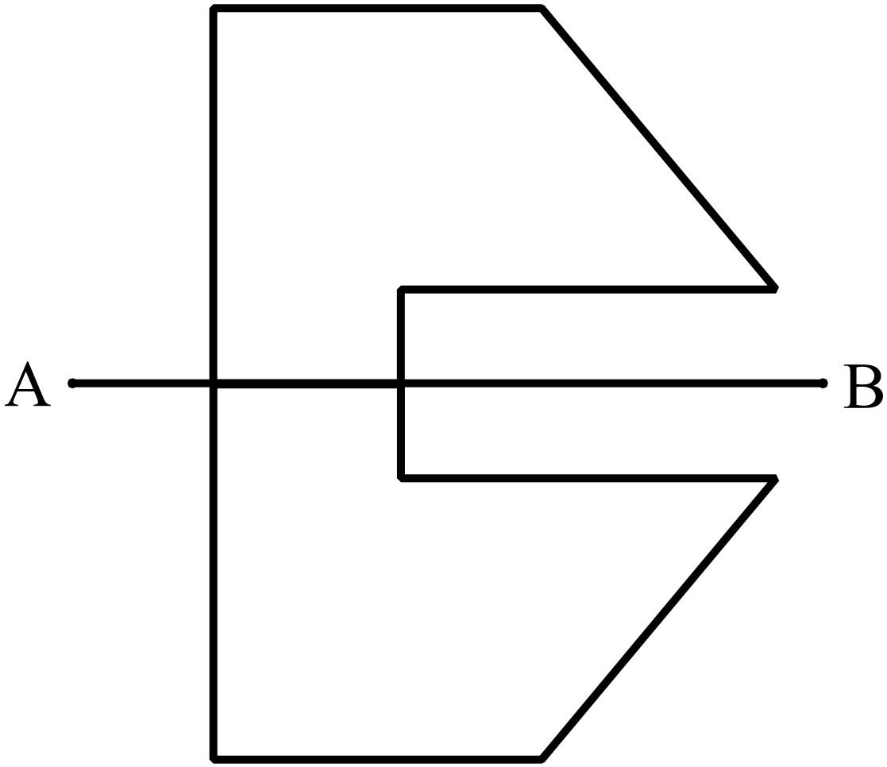

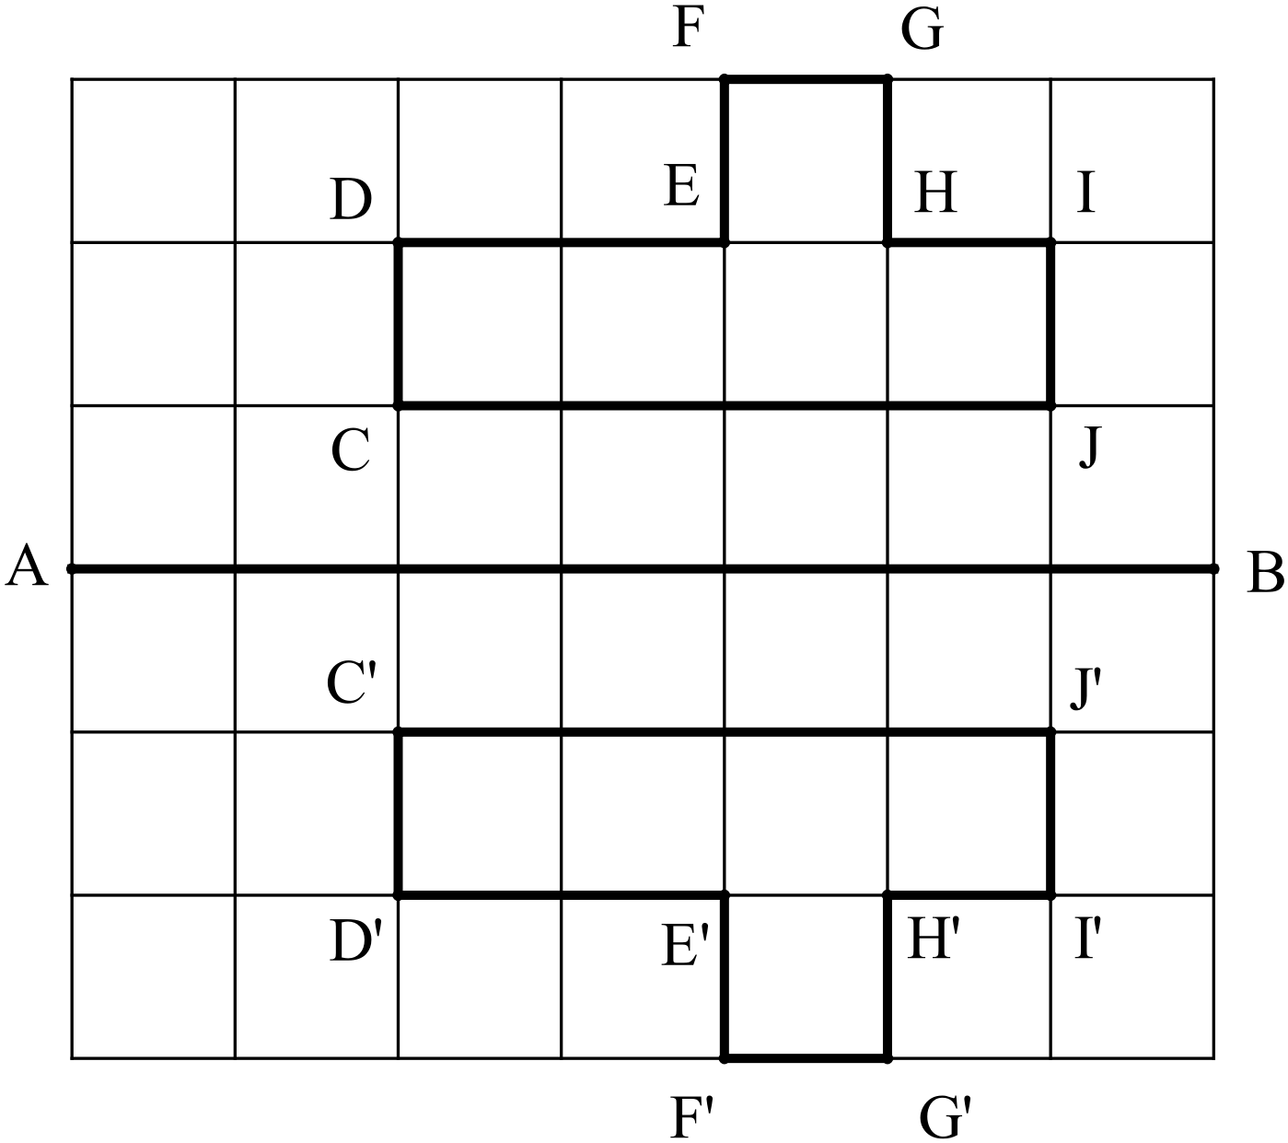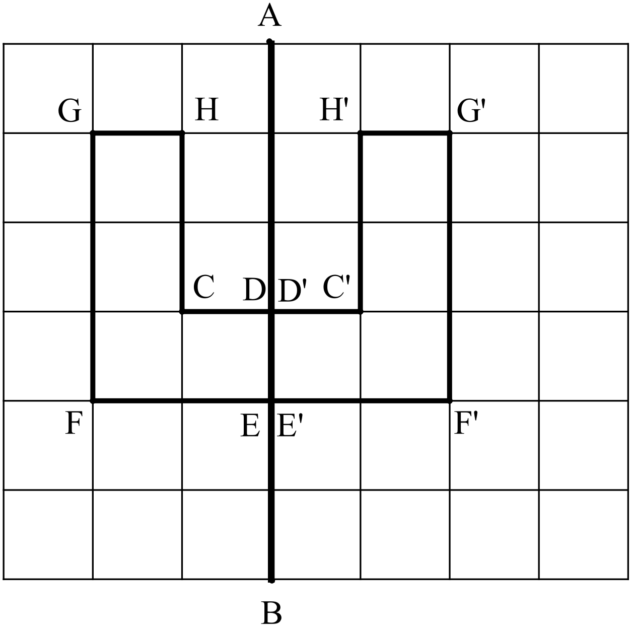

Question 4
Reflect the following objects over the line XY labelling the vertices of the image appropriately.
- 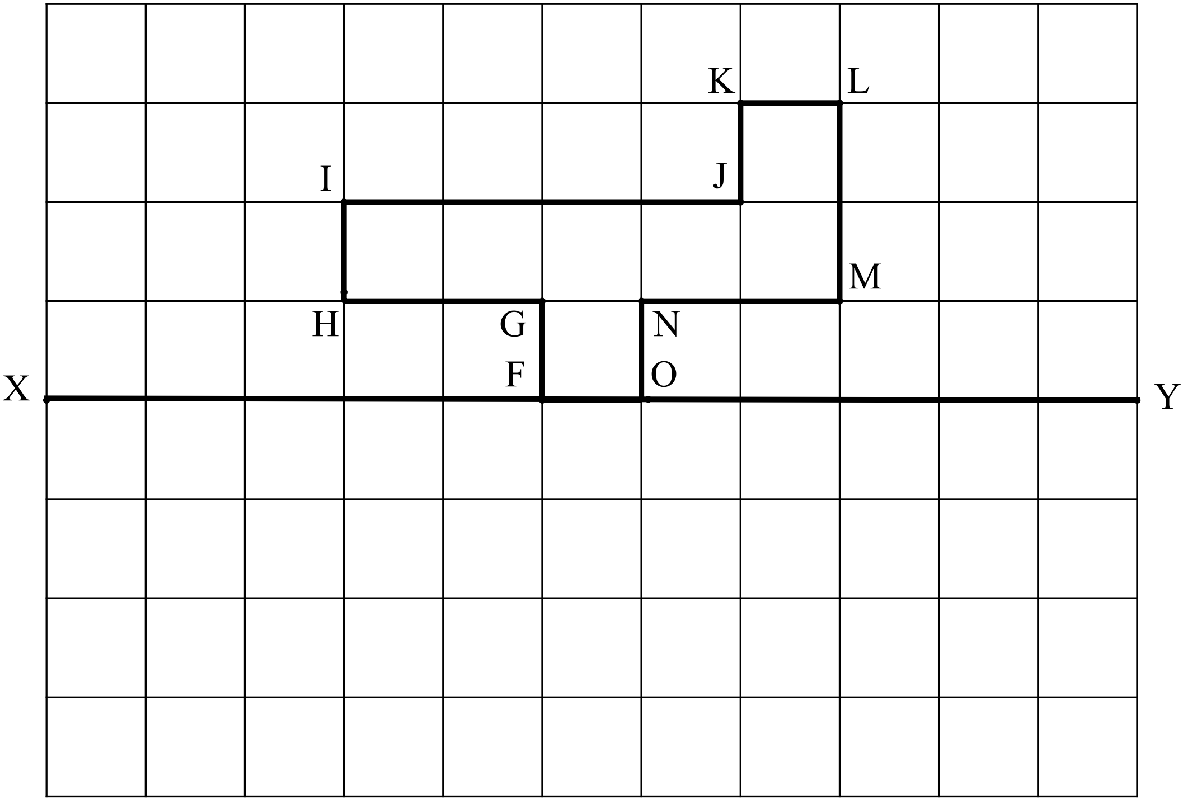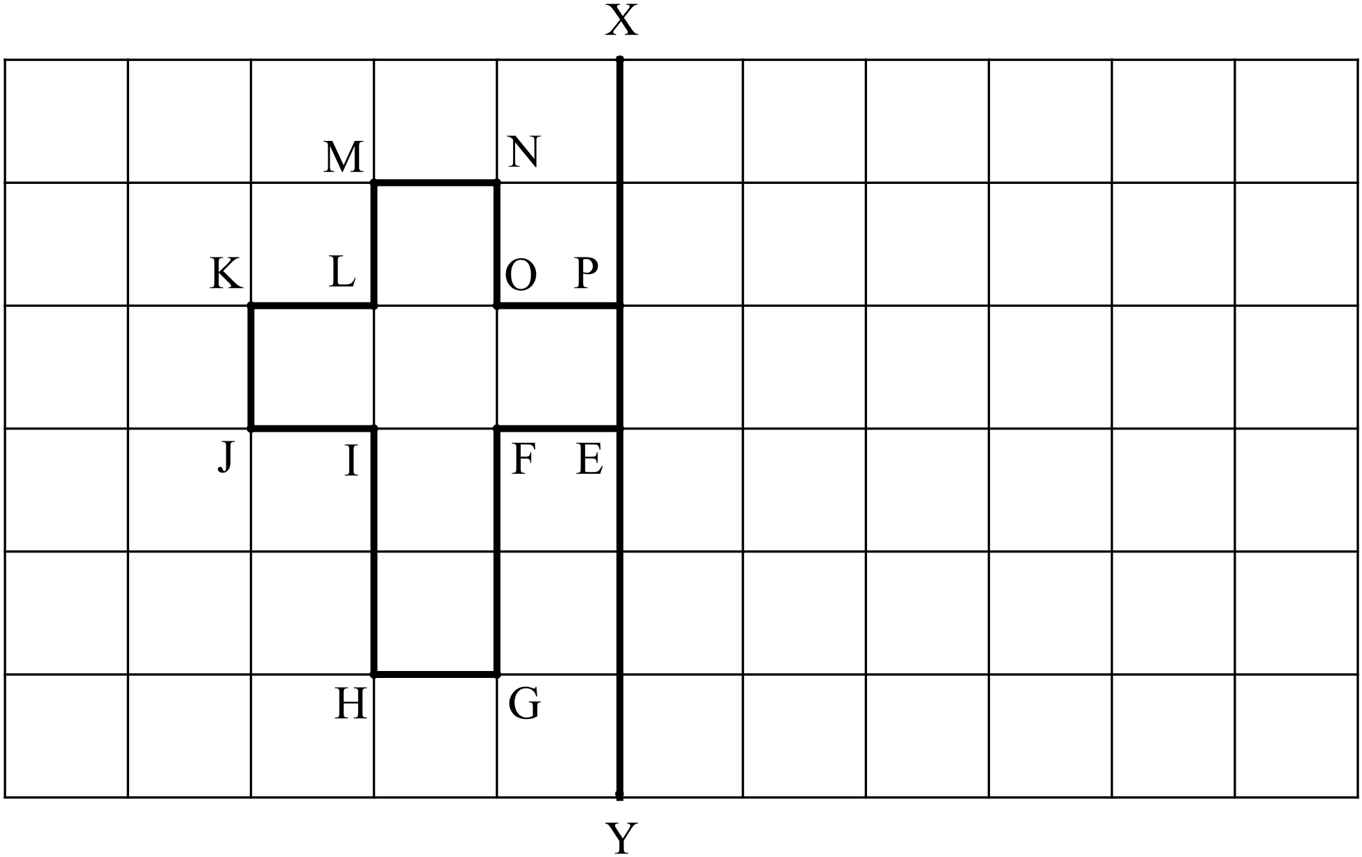 b)

Rotations
A Rotation is a ‘turn’ around a point by a given angle.
A rotation can ‘turn’ clockwise or anticlockwise.
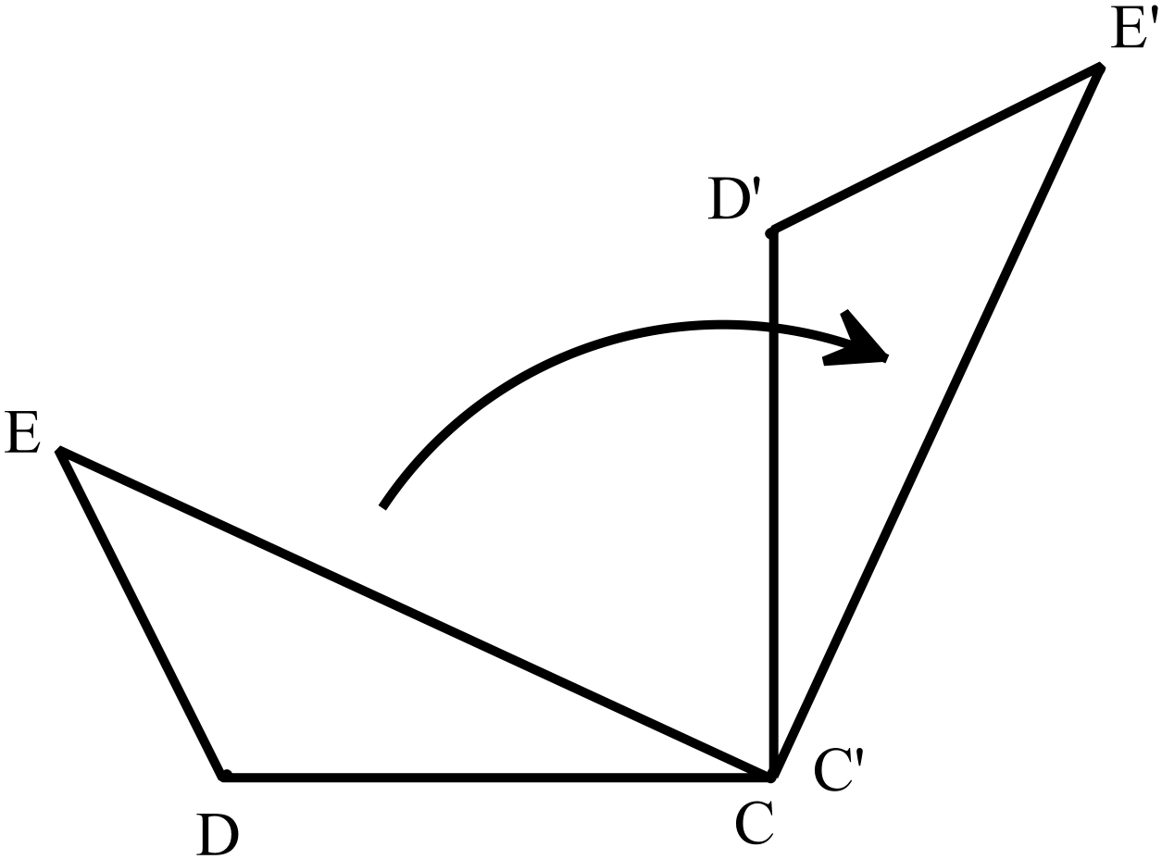We will only be considering rotations of 90°, 180°, 270° or 360°.

Object CDE has been rotated 90° clockwise around point C.

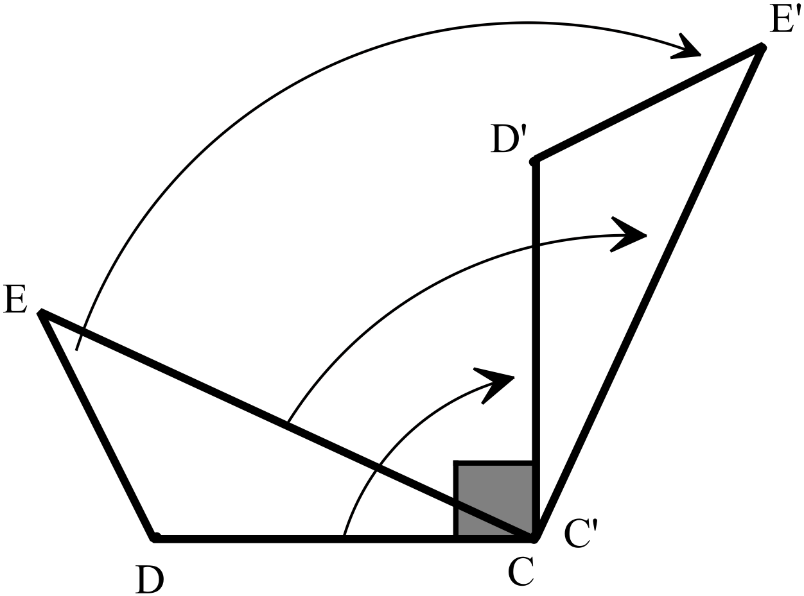

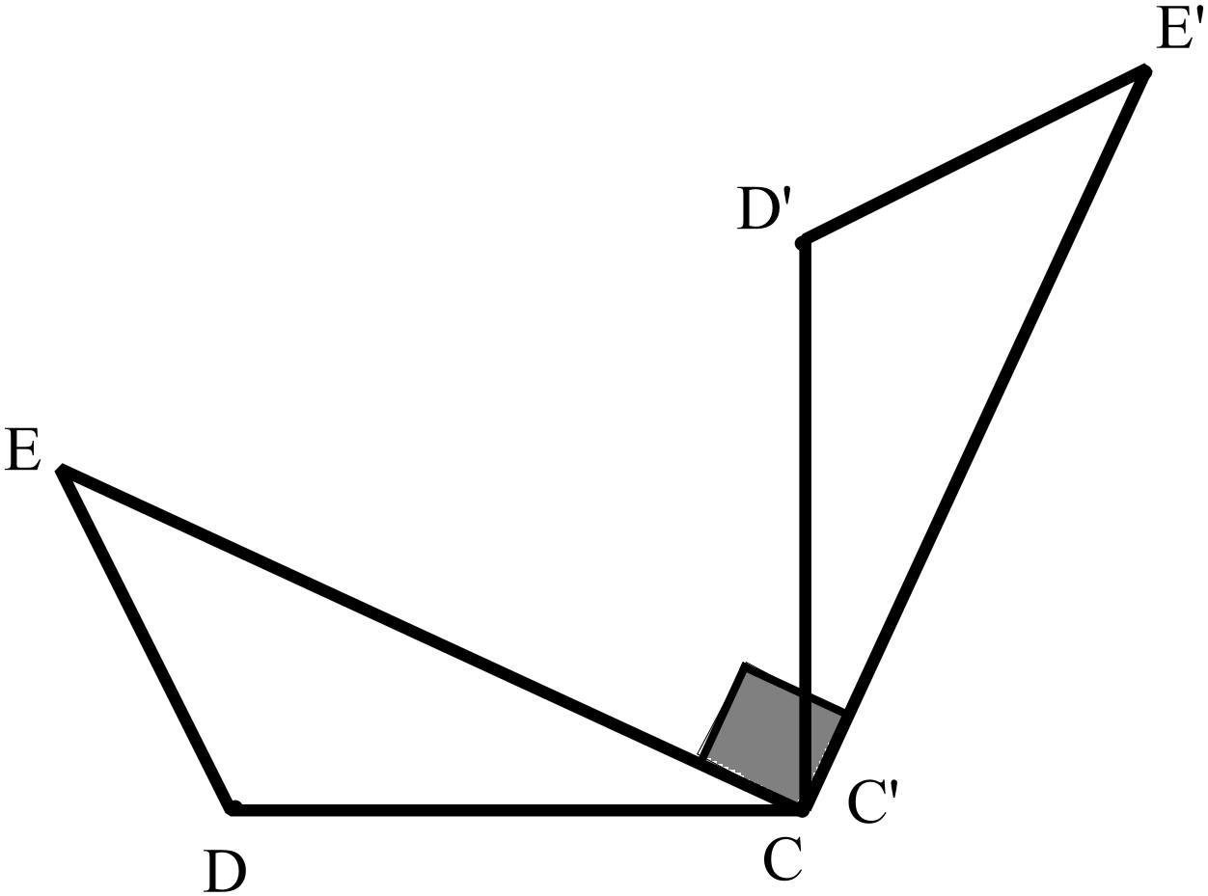Notice that there is 90° between CD and C’D’
i.e.

There is also 90° between CE and C’E’
i.e.

Question 6
Rotate the following objects, labelling the vertices of the image appropriately:
- 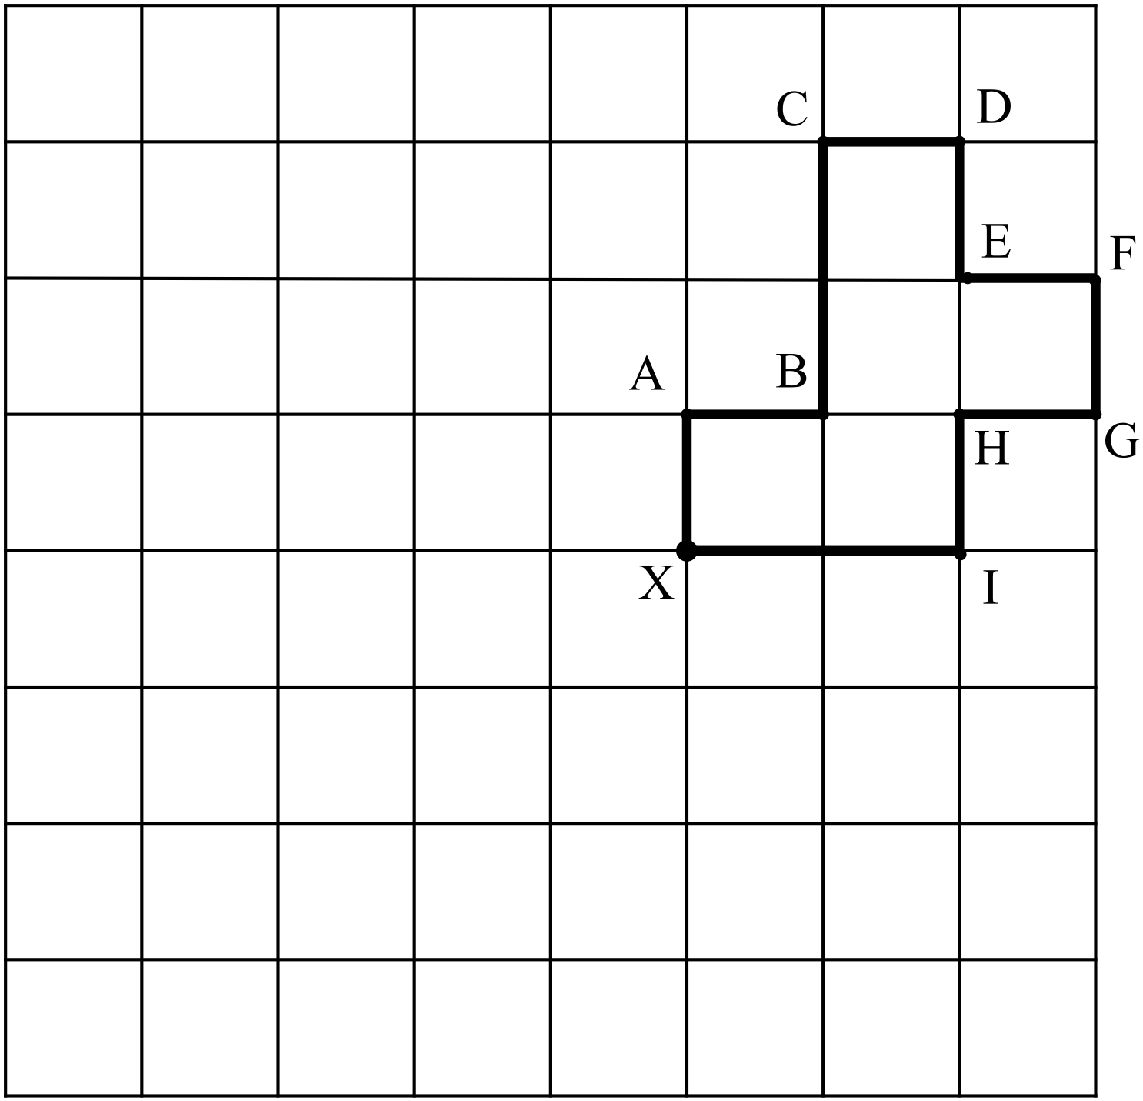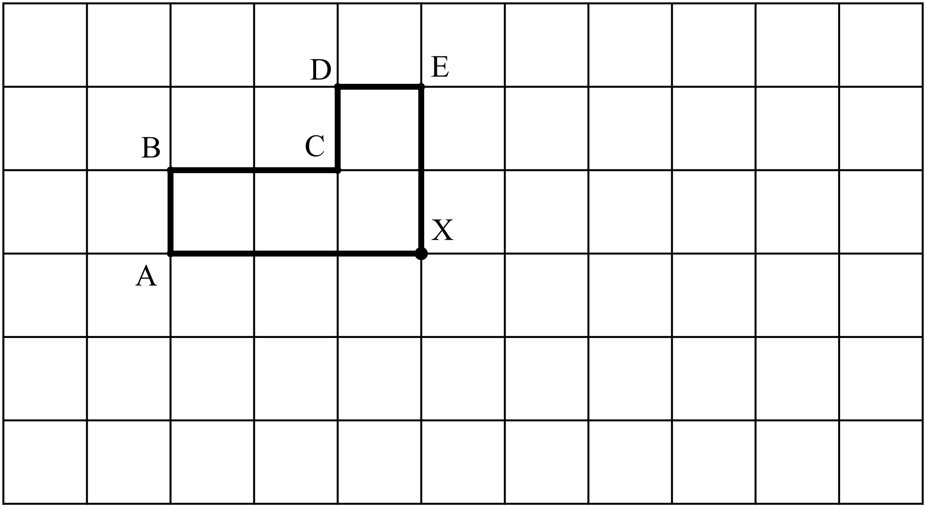 180° about point X b) 90° clockwise about point X

- 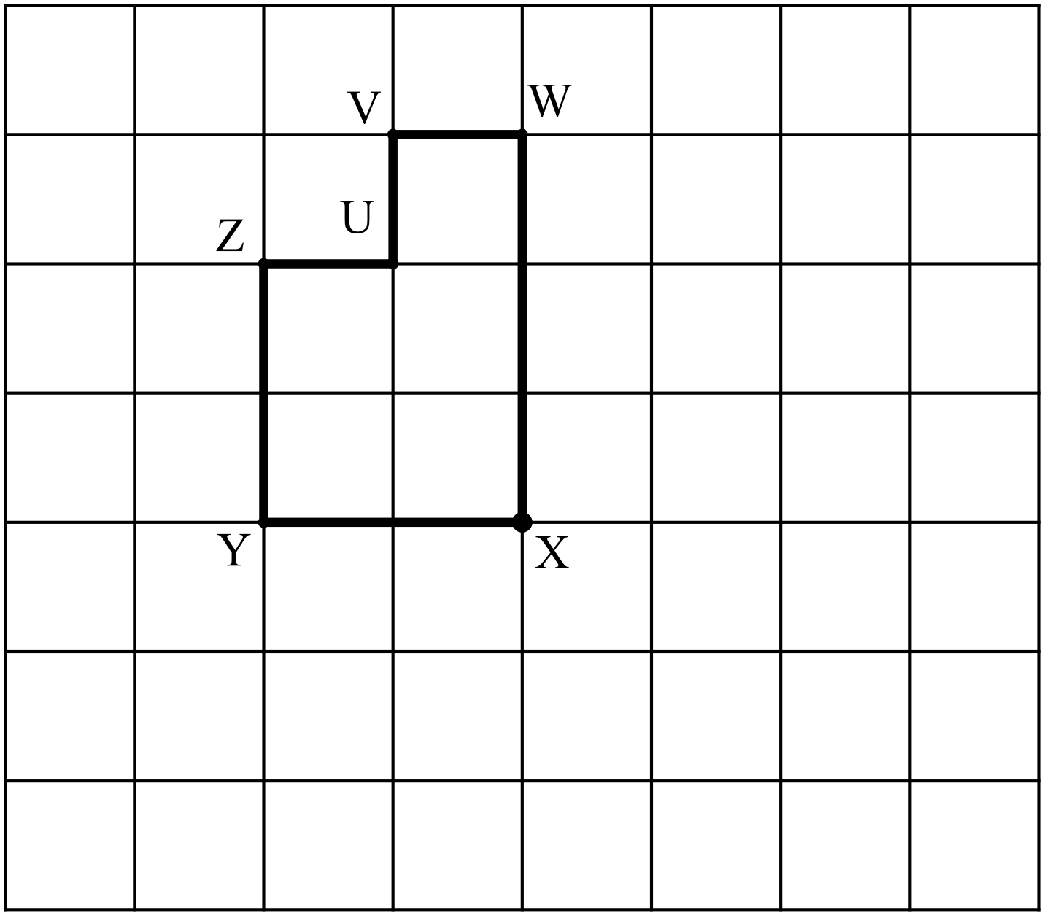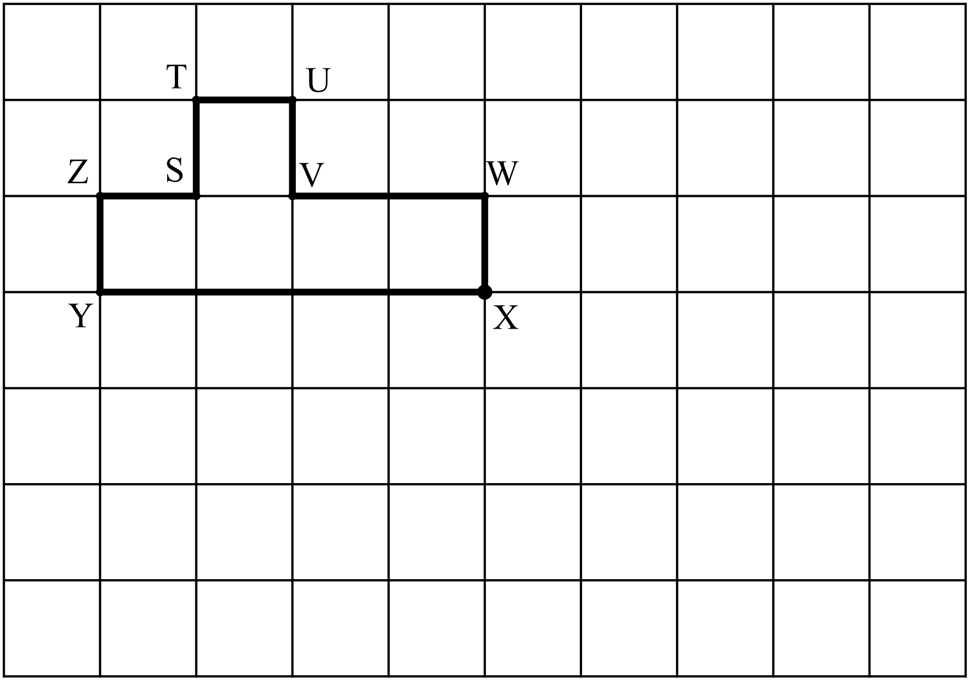90° anticlockwise about point X d) 270° clockwise about point X

